CryptoShield: Data Encryption and Security

A Capstone Project
Presented to the Faculty of the
College of Information Technology Education
PHINMA University of Iloilo

In Partial Fulfillment
Of the Requirements for the degree
Bachelor of Science in Information Technology

By:
Colin Maria Pampango
Frinces Joy Patenio
Melesa Gabayeron

June 2026

Approval Sheet

In partial fulfillment of the requirements for the
Bachelor of Science in Information Technology, this
Capstone Project entitled Cryptoshield:Data Encryption
and Security prepared
And Submitted by Colin Maria Pampango, Frinces Joy Patenio and Melesa Gabayeron who are hereby recommended for corresponding final evaluation.

Krislyn Sinoy
Adviser

Approved by the Panel of Evaluation with a grade of PASSED

Dr. Arnold M. Fuentes, Ph. D, MPA, MMIT
Chairman

Accepted in partial fulfillment of the requirements of
the Bachelor of Science in Information Technology

Seth dA. Nono, MSCS
CITE, DEAN OF DEANS
ACKNOWLEDGEMENT

First, we would like to thank ourselves for trying our best without giving up. For all of the things we’ve been through together, we three ended with the same decisions throughout while thinking of ideas for our capstone project which we are thankful for.

We would like to thank God for guiding us in the above and of course for giving us the lives that we have right now that allow us to think creative ideas about our Capstone Project. We also like to thank God for giving us a healthy body so that we are able to finish Capstone without any problem in our health.

We are also thankful to our teachers for the past years at this school, you taught us what we should learn, thank you for your guidance, patience and dedication. It was not because of you that we would not be where we are today.

To our Family and Friends, we want to take a moment to acknowledge the love, support, and strength of our family and friends. Each of you brings something unique to the table, and together we create a bond that is unbreakable. Thank you.

ABSTRACT
As we continue to move deeper into the digital age, the way we store, share, and communicate sensitive information has never been more important—and neither have the risks of cyber threats. From small communities managing citizen records to organizations exchanging confidential reports, the need for strong, reliable tools to protect critical data is greater than ever. Traditional security measures are no longer enough on their own.
This is the motivation behind CryptoShield—a security-focused platform designed to safeguard digital communication and file sharing through advanced encryption and controlled access.
CryptoShield combines the power of modern cryptographic algorithms to deliver layered security. It uses Advanced Encryption Standard (AES) for fast and efficient symmetric encryption, ideal for securing large files and documents, and RSA for asymmetric encryption, ensuring secure key exchanges and making sure only authorized recipients can decrypt the information. This combination enables end-to-end encryption, keeping data secure from the moment it’s sent until the moment it’s decrypted by the intended recipient.
Beyond encryption, CryptoShield strengthens access control by allowing administrators to define user roles and permissions—ensuring that only the right individuals can view or handle specific files or folders. Uploaded files are automatically encrypted, and senders can decide exactly who can access them. This is especially valuable for organizations handling confidential records, legal documents, or sensitive communications.
Another core feature is encrypted messaging, providing a secure channel for private conversations. Whether it’s a leader communicating with their team or a secretary sharing a confidential update, messages remain protected from interception or tampering.
By integrating these measures—file encryption, message encryption, role-based access, and secure file sharing—CryptoShield offers a comprehensive, easy-to-use solution for any organization that values privacy and data integrity. In an era where digital security is constantly under threat, CryptoShield ensures sensitive information stays in the right hands.

TABLE OF CONTENTS

Title page—-----------------------------------------------i

Approval Sheet—------------------------------------------ii

Acknowledgement—----------------------------------------iii

Abstract—------------------------------------------------iv

Table of Contents—----------------------------------------v

List of figures—-----------------------------------------vi

List of tables—-----------------------------------------vii

CHAPTER I

Introduction—--------------------------------------------1

Background of the Study—-----------------------------

Statement of the Problem—----------------------------

Objectives of the Study—-----------------------------

Significance of the Study—---------------------------

Scope and Limitation—--------------------------------

CHAPTER II

Literature Review—----------------------------------------

Overview—--------------------------------------------

Traditional VS Modern System—------------------------

Technology Use—--------------------------------------

Case Studies—----------------------------------------

CHAPTER III

Methodology—----------------------------------------------

Research Design—-------------------------------------

Model Use—-------------------------------------------

Data Flow Diagram—-----------------------------------

Entity Relationship Diagram—-------------------------

CHAPTER IV

Result and Discussion—-----------------------------------

System’s Features—----------------------------------

Implementation Challenges—--------------------------

User Feedback—--------------------------------------

Comparison to other System—-------------------------

CHAPTER V
Conclusion and Recommendation—------------------------

Conclusion—--------------------------------------

Recommendation—----------------------------------

Final Thoughts—----------------------------------

CHAPTER VI

Appendices—-------------------------------------------

Screenshots—-------------------------------------

Curriculum Vitae—--------------------------------

Grammarian Certificates—-------------------------

Chapter 1
Introduction to the Study
The goal of this capstone project is to be an integrated solution that will be an all-encompassing and safe communications and file-transfer platform designed to safeguard end-user data through strong encryption techniques and multi-layered security measures. The user interface is designed to be user-friendly, such that it guarantees ease and strong protection for sensitive information. The system starts from a secure login process, where a user has to authenticate themselves using a traditional username and password, followed by a One-Time Password (OTP) sent via email. This two-factor authentication adds security, making it much more difficult for unauthorized users to access information.
Users authenticated are allowed to share messages that are encrypted using a hybrid encryption, the AES algorithms. In a symmetric encryption method, AES, the message itself is encrypted. This guarantees the secrecy with efficiency of the communication. Messages sent through the platform are encrypted end-to-end and cannot be opened by anyone other than the target recipient, thereby protecting them from interception or tampering.

This does not stop at secure messaging, but that system is capable of encrypting and decrypting user files using AES encryption. With this, all files saved or moved through these systems are protected from unauthorized access. Additionally, every file is subject to malware scanning.

Technical Background of the Study
Today, with an impending digital environment, securing a channel through which an individual or organization transmits files and communicates becomes most critical. Individuals and organizations are becoming wholly dependent on online platforms for exchanging information, all of which provide an all-encompassing platform for vulnerabilities brought about by cyberattacks, breaches of data, and unauthorized access. The majority of conventional systems do not have sufficient protection against such an event and leave users threatened by identity theft, unauthorized messages, and exposure to malware. Most platforms either transmit unencrypted data or have weak security, making them potentially insecure for attackers to exploit. Hence, developing such systems that would offer security in terms of confidentiality, integrity, and authentication from unauthorized access becomes a pressing need.

To solve these emerging problems, the research presents a secure communication and file-sharing system that incorporates new methods of encryption and protective features. The data will be sent through AES encryption, whereby it will make sure every message remains encrypted throughout the whole process, and only the receiver will be able to decrypt it. For files, AES encryption shall also be secure login to the system will feature OTP (One-Time Password) that prohibits unauthorized access.

Statement of the Problem
Many communication and file-sharing systems today do not provide enough security to protect users’ data. Users often face risks like unauthorized access, a lack of strong encryption, and the possibility of sharing malware-infected files. There is also a problem with files being accessed or decrypted by people who should not have permission. Here are the following challenges:
- Existing communication and file-sharing platforms often lack robust security measures, leaving data vulnerable to unauthorized access and cyberattacks.
- Many systems do not implement strong encryption for messages and files, increasing the risk of interception and data breaches.
- User authentication methods are frequently insufficient, lacking multi-factor authentication, such as OTP verification, to prevent unauthorized logins.
- Files shared on current platforms can be accessed or decrypted by unintended users, leading to potential data leaks and misuse.
To address that issue, our system solves these problems by using OTP for secure login, AES for encrypting messages, and AES for encrypting files. This creates a safe and secure environment for communication and file sharing.

Objectives of the Study
This study is to develop a secure system that protects users’ messages and files. This capstone project aims to perform the following objectives:
- To develop a secure login system with OTP verification to prevent unauthorized access.
- To implement message encryption and decryption using AES algorithms to ensure confidentiality.
- To enable file encryption and decryption using AES to protect data privacy during storage and transfer.
- To design a secure file-sharing mechanism that restricts access and decryption only to intended recipients.

Significance of the Study
This study solves the problem of growing concern regarding data security and privacy in digital communication and file sharing. By strong encryption and secure authentication, the system helps protect the most sensitive information from unauthorized access and cyber threats. The secure file-sharing feature guarantees access only to intended recipients, thereby enhancing trust and confidentiality. Overall, this study enhances the safety of online communication and file management, helping individuals and organizations that favor protecting their data.

Key Benefits of the Study:
- Improved Security: AES encryption protects messages and files from unauthorized access.
- Enhanced User Authentication: Uses OTP-based login to add an extra layer of account protection.
- Safe File Sharing: Ensures that only intended recipients can access and decrypt shared files.
- Confidential Communication: Secures message exchanges, keeping conversations private and protected.
- User Trust and Confidence: Builds user trust by offering a secure and reliable digital environment.
- Practical Application: Can be used by individuals, businesses, or institutions needing secure data exchange.

Beneficiaries
- Registered Users of the System
Individuals who will directly use the platform to securely send messages and share files, ensuring their data remains private and protected.
- Small Business Owners
Entrepreneurs and small business teams need a cost-effective and secure way to communicate and share documents without the risk of data breaches.
- Teachers and Students in Online Learning Environments
Educators and learners who need to share academic files and communicate securely during online classes or assignments.
- IT Staff and System Administrators
Professionals responsible for maintaining secure digital systems can benefit from the system’s features and possibly implement or manage similar platforms.

- Government Employees Handling Confidential Files
Staff working with sensitive government documents who require a platform where files can be securely encrypted, shared, and accessed only by authorized personnel.

Scope and Limitation of the Study
This section outlines the boundaries and capabilities of the developed secure communication and file-sharing system. The scope defines the core functionalities the system offers, such as secure login, OTP verification, message and file
encryption/decryption using AES, and secure file sharing. The limitations highlight the current constraints and potential challenges the system faces, including reliance on SMS services, key management complexity, and system-bound file access. Understanding both aspects is crucial for evaluating the system’s effectiveness and areas for future improvement.
- User Authentication via Login System:
-Provides secure access using a credential-based login.
-Prevents unauthorized access through standard authentication mechanisms.
- OTP Verification via Text Message:
-Adds an extra layer of security with OTP sent via email.
-Validates user identity during login or sensitive operations.
- File Encryption and Decryption:
-Implements AES encryption for securing files.
-Ensures only authorized users can access and decrypt the files.
- Secure File Sharing:
-Files shared are encrypted and bound to the intended recipient.
Ensures that even if intercepted, files cannot be decrypted by unauthorized users.

Limitations of the Study
- OTP Delivery Dependence:
- Relies on the availability and reliability of SMS services.
- Users without mobile access may face difficulty.
- No Biometric or Advanced MFA:
-Lacks more modern and secure authentication methods (e.g., fingerprint, TOTP apps).
- Key Management Complexity
-AES key storage and handling are critical—mismanagement could compromise security.
-The system needs secure key exchange and storage mechanisms.
- Encryption Overhead:
-Encrypting/decrypting large files can be resource-intensive.
-May impact performance on low-end devices.
- File Sharing Bound to System:
-Files can only be shared and decrypted within the system.
-Users cannot decrypt files outside the platform, limiting flexibility.
- No End-to-End Encryption (if not implemented):
-If encryption/decryption occurs on the server, admins could potentially access data.
-For true privacy, client-side encryption/decryption is preferred.
- Scalability & Performance Not Addressed:
-System performance under high traffic or large-scale use hasn't been detailed.

Definition of Terms
- Login System
A mechanism that verifies a user's identity using credentials (e.g., username and password) to grant access to the system.
- OTP (One-Time Password)
A time-sensitive code sent to a user (typically via email) is used as a second layer of authentication to verify identity.
- Encryption
The process of converting plaintext data into a coded form (ciphertext) to prevent unauthorized access.
- Decryption
The process of converting encrypted data back into its original readable form using a specific key.
- AES (Advanced Encryption Standard)
A symmetric encryption algorithm is used to encrypt large amounts of data securely and efficiently.
- Symmetric Encryption
An encryption method where the same key is used for both encryption and decryption.
- Asymmetric Encryption
An encryption method that uses a pair of keys: a public key for encryption and a private key for decryption.
- Secure File Sharing
A method of transmitting files between users in a way that ensures only the intended recipient can decrypt and access the file.
- Confidentiality
A security principle that ensures information is only to those authorized to view it.

Chapter II
Review of Related Literature
Related Literature
According to Arief Budi Pratomo et al.(2023), the speedy advancement of digital technology (p.3) has brought about a surge in the production, storage, and sharing of data across different information systems. The digital revolution is of immense value, yet it poses risks with respect to the safety and privacy of personal data. Online attacks, data breaches, and unauthorized access have stressed the necessity for strict security features for safeguarding data systems that guarantee data privacy, availability, and integrity. Employ secure cryptographic techniques to encrypt data and secure it against unauthorized access. Use several authentication checks to verify the authenticity of users attempting to access sensitive data.
Prachi Goyal (2022), In the present era of digitization (p.2), the outburst of data-driven technologies has transformed how data is shared and stored. However, during this transition, the most important aspect to always keep in mind is the security and privacy of sensitive data. Encryption happens to be one of the core areas of cybersecurity, which plays a significant role in protecting digital data against unauthorized access and possible breaches. This discusses in detail the different aspects related to the significance of encryption for data protection investigates the general principles of encryption algorithms, their evolution through time, and consequently their importance in various areas-both to present a thorough analysis of current research works, practical applications, and industry practices capture the challenges and opportunities that encryption technologies present about the trade-off between the security and usability aspects of this technology.
Tunbosun, as per Oyewale Oladoyinbo et al.(2024), Data protection has become essential (p.10) in the contemporary technology-driven world as data violations rise due to advanced hacking methods. The importance of encryption algorithms in preventing unauthorized access without the corresponding decryption key is essential for individuals and organizations alike examines various types of data encryption techniques, including asymmetric and symmetric encryptions such as Data Encryption Standard (DES), Advanced Encryption Standard (AES), and Rivest-Shamir-Adleman (RSA) algorithms play a crucial role in enhancing data security by safeguarding against threats like ransomware, social engineering tactics, and insider risks and comprehensive literature review and actual study investigate the significance of data encryption algorithms in maintaining data security.

References
Data encryption and anonymization techniques for enhanced information system security and privacy
Arief Budi Pratomo, Sabil Mokodenseho, Adit Mohammad Aziz
West Science Information System and Technology 1 (01), 1-9, 2023
https://www.academia.edu/download/108004208/185.pdf

The Importance of Data Encryption in Data Security
Prachi Goyal
Journal of Nonlinear Analysis and Optimization 13 (1), 2022
https://jnao-nu.com/Vol.%2013,%20Issue.%2002,%20July-December%20:%202022/1.pdf

Tunbosun Oyewale Oladoyinbo, Oluseun Babatunde Oladoyinbo, Adeyemo Isiaka Akinkunmi(11 (2), 10-16, 2024
)https://www.academia.edu/download/113543831/The_Importance_of_Data_encryption_Algorithm_in_Data_Security.pdf

Chapter 3
Methodology
The system was developed with a strong focus on secure communication, user authentication, and safe file sharing. To begin with, users must authenticate themselves by logging into the system using a secure login process. To add an extra layer of security, the system incorporates a One-Time Password (OTP) verification mechanism. This OTP is sent via email or SMS and must be entered within a limited time, helping to prevent unauthorized access.
For secure messaging, the system uses AES encryption to ensure the confidentiality and integrity of user communications. When a user sends a message, the content is first encrypted using a randomly generated AES key for fast and efficient encryption. This ensures that messages remain private and protected from unauthorized access throughout the transmission process.
In terms of file handling, the system ensures both safety and confidentiality by encrypting each file using a unique AES key. This means that every file is individually protected, reducing the risk of data compromise. Secure file sharing is further strengthened by binding files to specific user accounts. Even if an encrypted file is intercepted or accessed by someone else, it cannot be decrypted or read unless the user is explicitly authorized.
The encryption keys are securely managed within the system to maintain data integrity and confidentiality. To further enhance security, the system implements additional features such as timestamping, nonce-based replay protection, and digital signatures, which help verify message authenticity and prevent tampering.
All major system activities—such as login attempts, file access, and encryption or decryption events—are securely logged to provide a complete audit trail. Together, these components create a robust and secure environment that allows users to communicate and share files safely.

Research and Development Stage
Understanding the current security landscape, user needs, and existing technologies. We started by reviewing the strengths and weaknesses of popular encryption algorithms, focusing on symmetric and asymmetric cryptographic methods. AES (Advanced Encryption Standard) was selected for its speed and efficiency in encrypting large data such as files and messages, while RSA (Rivest–Shamir–Adleman) was chosen for secure key exchange due to its proven reliability in public-key encryption.
Following the initial research, the design phase focused on integrating a hybrid AES encryption model
To achieve both security and performance. We studied how these encryption methods are implemented in real-world applications to guide our own architecture. Simultaneously, we researched malware detection approaches and selected a suitable antivirus engine that could be integrated to scan files before encryption and sharing. This step was crucial in ensuring that only safe files are transmitted, protecting all users in the system.
The development stage began with building the user authentication system, including secure login and OTP-based verification. We evaluated different OTP generation and delivery techniques to select a method that was both secure and
User-friendly. After that, we implemented the encryption and decryption modules, ensuring that AES keys were generated randomly for each session to maintain strong data security. These components were rigorously tested to prevent any potential vulnerabilities or data leaks.
File encryption and secure sharing were developed next, focusing on ensuring that only the intended recipient could decrypt and access shared content. We incorporated user-binding mechanisms so that encrypted files could not be accessed by unauthorized users, even if the files were leaked.
Throughout the R&D process, we conducted continuous testing, including functional testing, penetration testing, and performance benchmarking. Feedback from test users was gathered to refine the user interface and enhance usability without compromising security. The final system reflects a balance between strong encryption and a user-friendly experience, ensuring it meets the needs of individuals and organizations requiring secure communication and file sharing.
Model Used
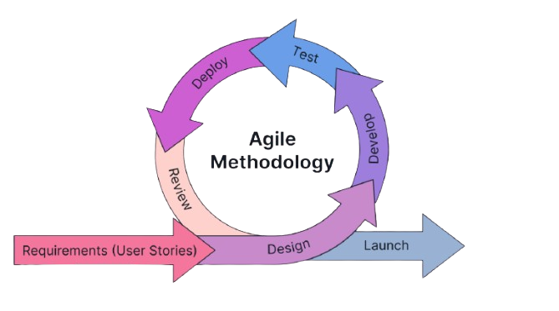
Figure 1. Agile Methodology
The project follows the Agile methodology, ensuring a structured and systematic approach to the development and deployment of CryptoShield. The agile process consists of the following phases:
- Requirements - In this phase, the proponents identified the system requirements, set the project goals, and defined the project scope. They also conducted an initial interview with one of the representatives of the client to understand their needs.
- Design - In this phase, the proponents created the system architecture and interface designs based on the gathered requirements. The team ensured that the design aligned with user needs and project objectives, providing a clear foundation for development.
- Develop - In this phase, the actual coding and implementation of system functionalities were carried out. The team worked in short, iterative cycles (sprints) to gradually build and refine system features.
- Test - In this phase, the developed modules were tested to ensure functionality, performance, and reliability. Errors and bugs were identified and resolved promptly to maintain software quality.
- Deploy - In this phase, the system was deployed in a real or simulated environment for client evaluation. The deployment allowed end-users to interact with the system and provide initial feedback.
- Review - In this phase, feedback from users and stakeholders was gathered to evaluate the system’s effectiveness. The team reviewed outcomes and identified areas for improvement, feeding insights into the next iteration of development.

Data Collection Techniques
To ensure that the system was developed in line with user needs and to evaluate its overall performance and functionality, a variety of data collection techniques were employed throughout the research, development, and testing phases. These techniques allowed us to gather both qualitative and quantitative data, which guided the system’s design, development decisions, and feature improvements.
- Survey – One of the primary data collection methods used was a Google Form survey. This allowed us to efficiently gather responses from users regarding their experience with the system, including ease of use, interface design, accessibility, and overall satisfaction. The collected responses helped identify usability concerns and provided suggestions for improvement to ensure that the final system met user expectations.
- Interview – In addition to the survey, group focus discussions and client requirement-gathering sessions were conducted to obtain a deeper understanding of user needs. These interviews involved open discussions with potential users and stakeholders to determine their specific requirements, desired features, and preferences for the system’s functions. The feedback gathered served as a vital reference during the design and development stages to ensure that the system addressed real user needs.
Together, these data collection techniques provided a comprehensive understanding of user requirements, system usability, and performance. The insights gathered were instrumental in refining the system and ensuring it effectively fulfilled its intended purpose.
Justification for Selecting the Agile Methodology
The decision to adopt agile over other SDLC models, such as Waterfall, was based on several critical factors:
Criteria | Agile Methodology | Waterfall Methodology
Flexibility | High - allows changes at any stage of development based on feedback or changing requirements. | Low - Changes are difficult when the phase is completed.
User Involvement | Encourages active user and stakeholder participation throughout the process, ensuring the product meets actual needs. | Users participate only during the requirements and testing phases.
Deployment | Done in small parts and updated often | Done only once after the whole project is finished.
Risk Management | Risks are identified early through continuous testing and feedback. | Risks are often discovered late in the project, which can lead to costly revisions.
Project Sustainability | Promotes long-term sustainability by supporting adaptive planning, continuous improvement, and team collaboration. | Sustainability is harder to maintain due to inflexible processes and delayed feedback loops.

System Architecture and Design
Overview
The Crytoshield system was designed to improve the security and file activities of barangay officials. The architecture follows the three-tier architecture to ensure scalability, reliability, and efficient data management for securing confidential files of the barangay. This architecture separates the system into three logical layers-Presentation Tier, Application Tier, and Data Tier- each responsible for distinct functions that work together seamlessly.

System Architecture
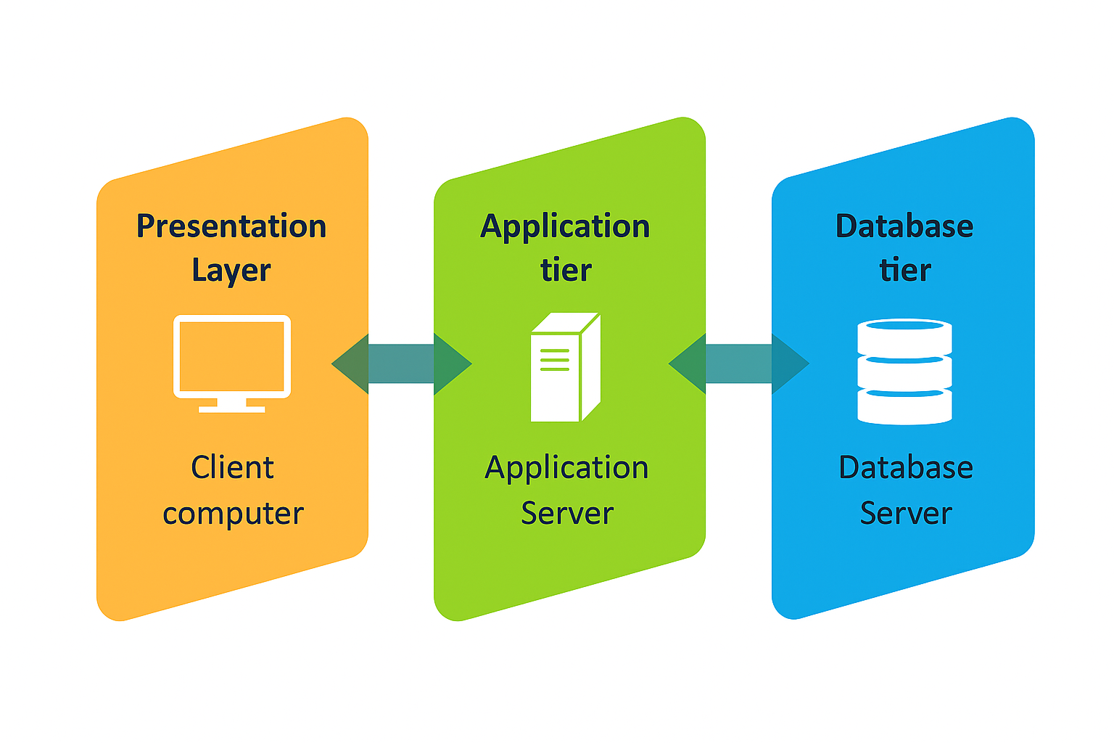
Figure 2. System Architecture

The system architecture is divided into three main layers:
- Presentation Layer - serves as the user interface of the system. It is responsible for displaying information to users and collecting their input. This tier is typically implemented using web technologies such as HTML, CSS, Bootstrap, and JavaScript, providing an interactive and user-friendly experience. It communicates with the Logic Tier to send and retrieve data as needed.
- Application Layer - handles the core operations and processes of the CryptoShield system. It is responsible for managing system logic, validating inputs, handling user authentication, processing inventory transactions, and generating reports. This layer acts as a bridge between the Presentation and Data Tiers, ensuring smooth data exchange. It is typically implemented using PHP or another server-side scripting language.
- Data Layer - The Data Tier manages data storage, retrieval, and maintenance. It contains the database where all records, transactions, and logs are securely stored. This layer ensures data integrity and supports queries executed by the Application Tier. It uses MySQL for reliable data management and fast access.
System Components and Modules
Landing Page
Figure 3 serves as the first point of interaction between the user and the application.
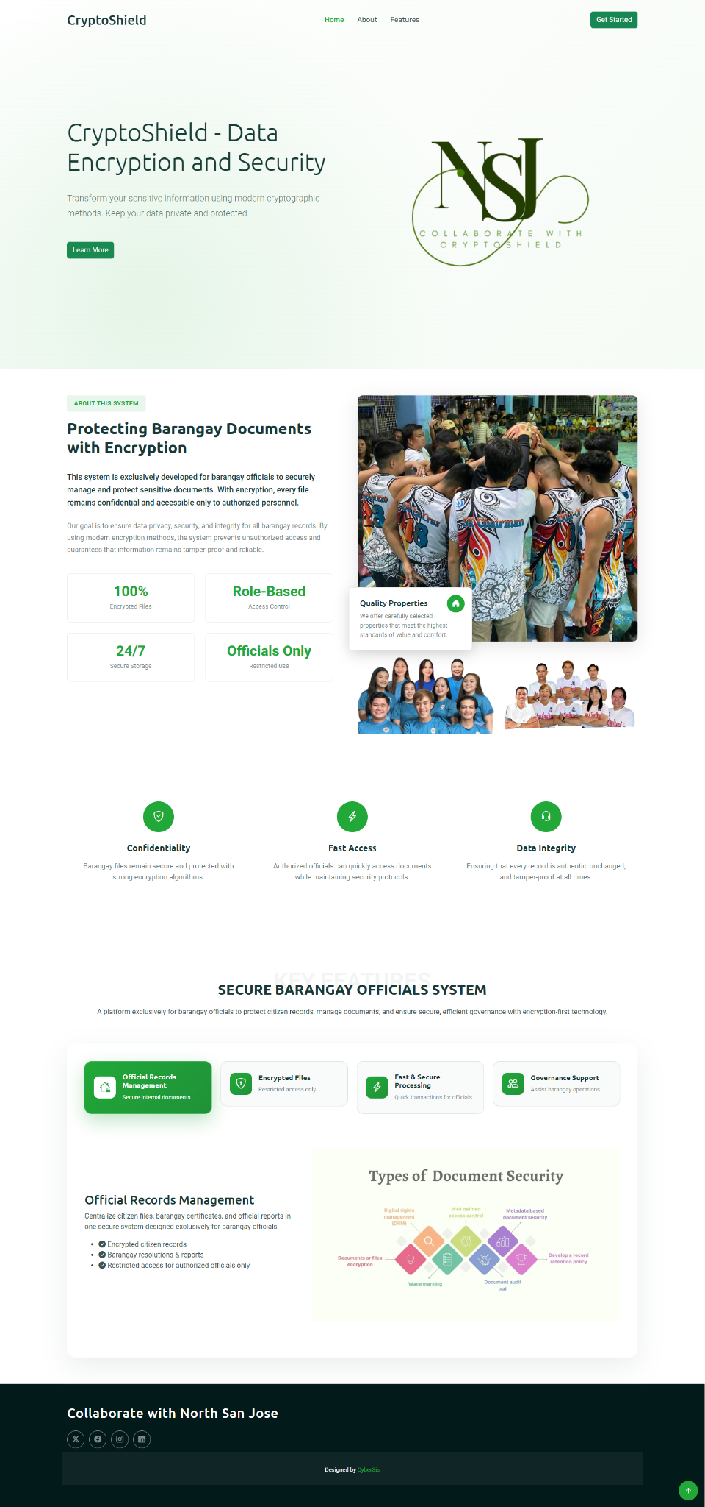
Figure 3. Landing Page
Type of Selection Interface
Figure 4 serves as a user role gateway. It ensures that users are directed to the correct dashboard based on their selected role.

Figure 4. Account Type - Selection Interface

Login Module
The login interface of CryptoShield System. This allows the user to securely access the system using their credentials.
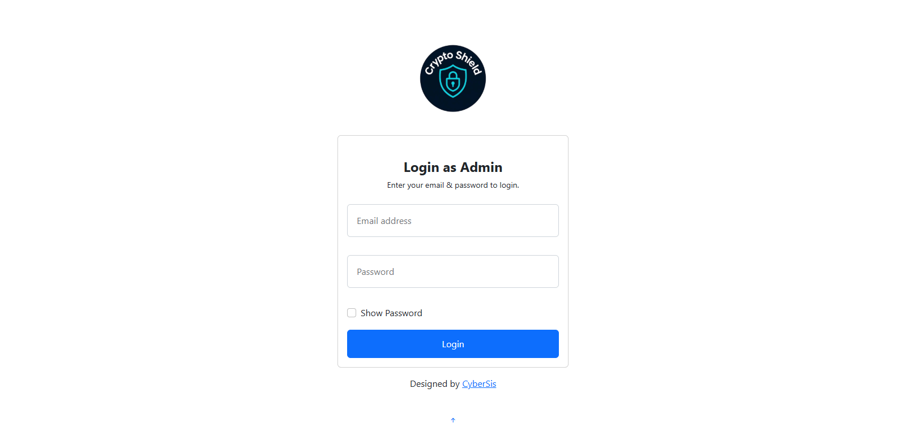
Figure 5. Login Interface of the System

User Dashboard
The main interface is presented after a successful login. Each type of user has a unique dashboard tailored to their responsibilities within the system.
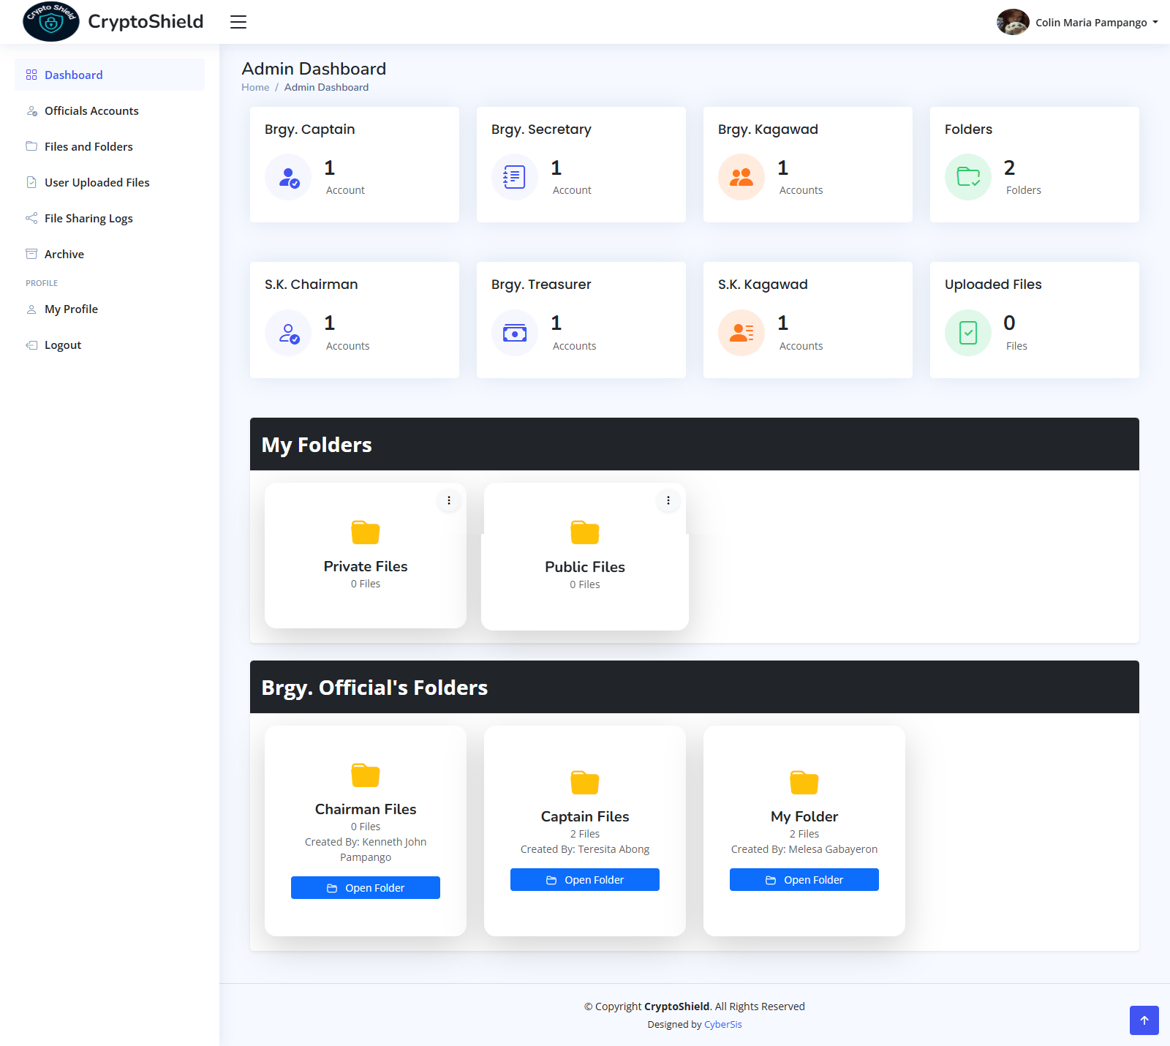
Figure 6. Admin Dashboard
File Sharing
displays the modules where the user can send a file to other users.
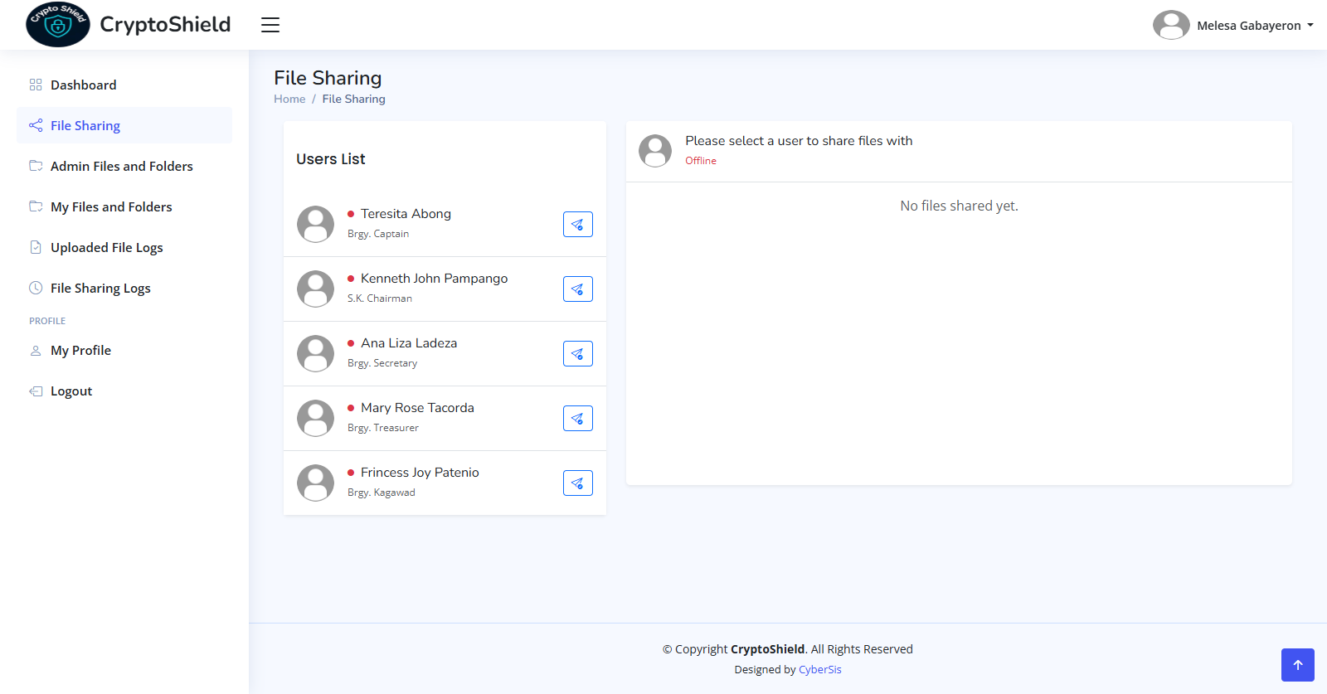
Figure 7. File Sharing Module

Create a Folder and Upload Files
Displays where users can create a Folder and upload files, and can set permissions for who can only open the folder/file.
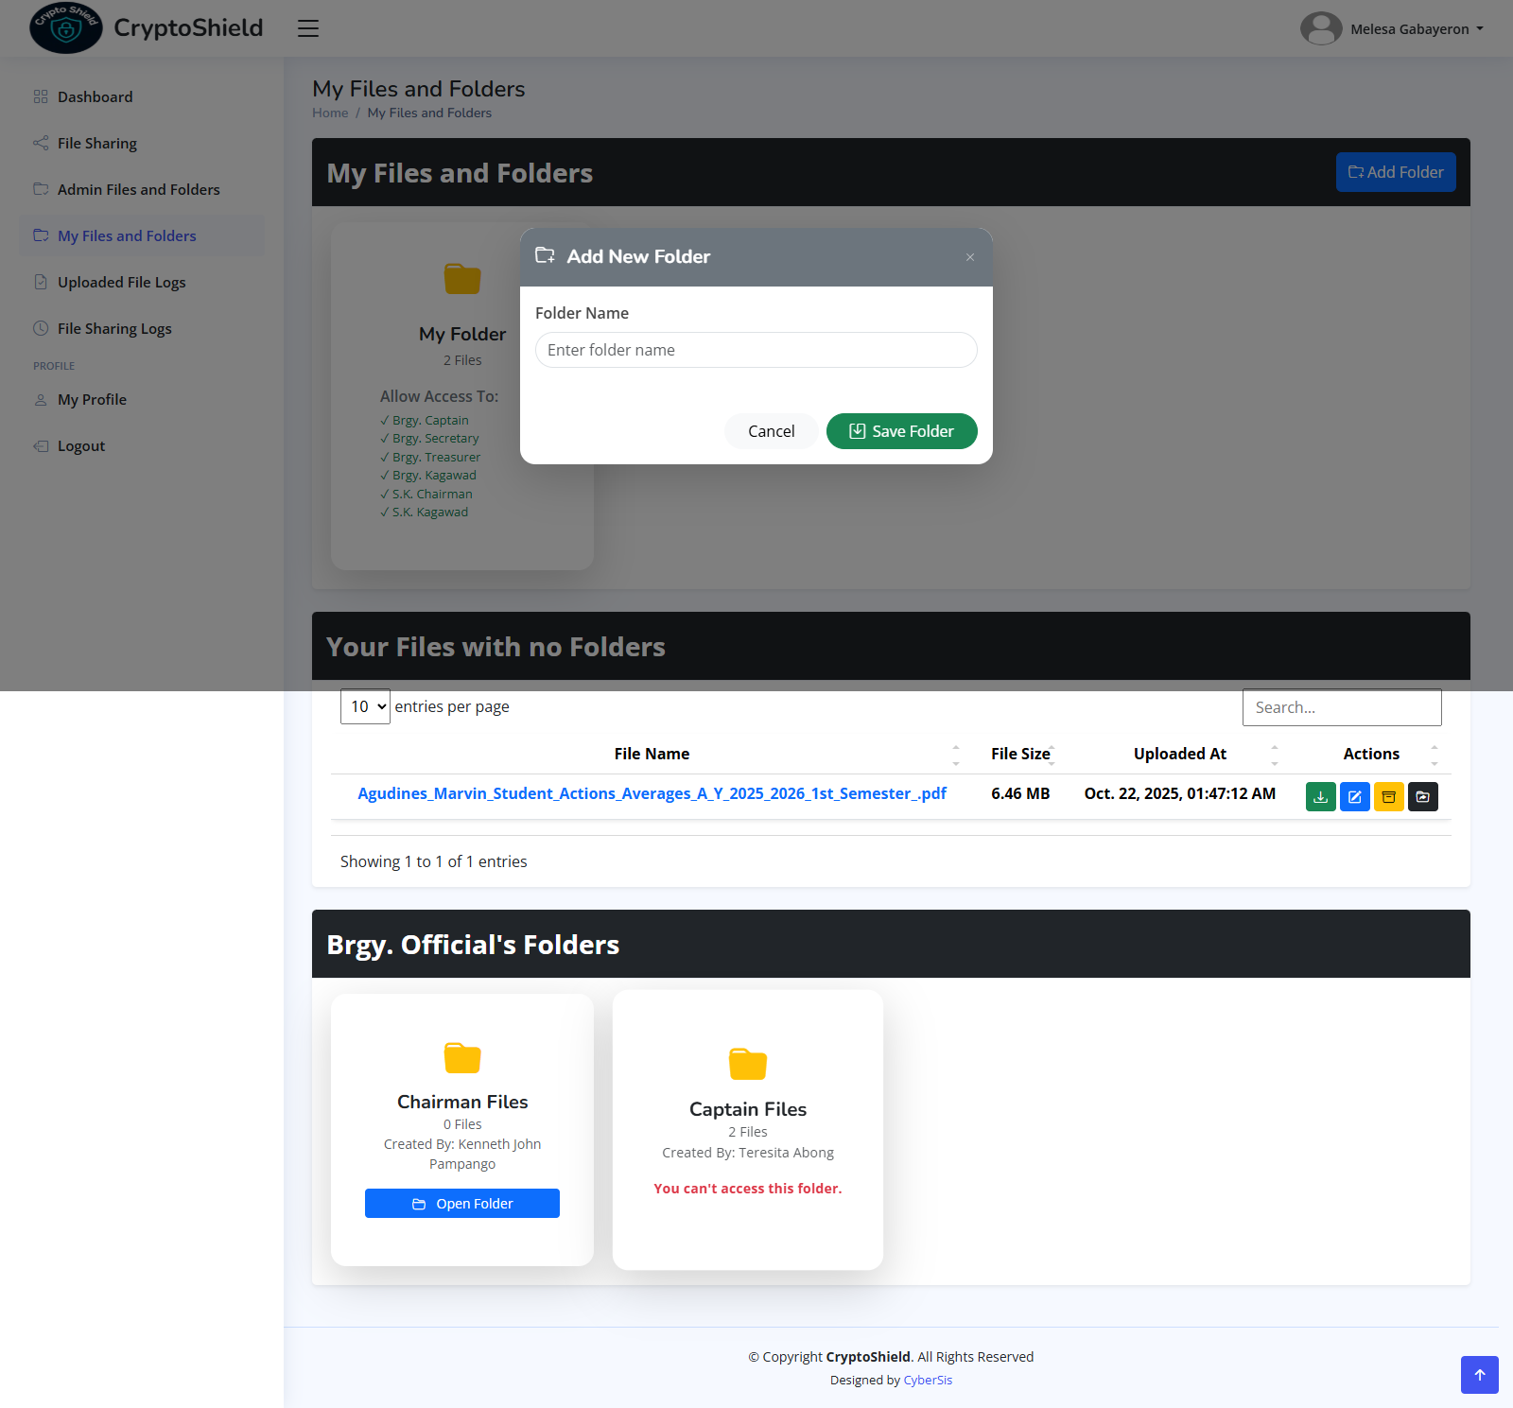
Figure 8. Create a Folder and Upload a File

Use Case Diagram
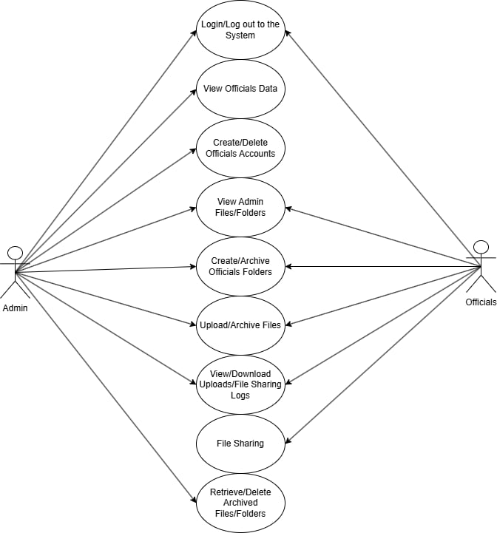
Figure 9. Use Case Diagram

The Diagram shows that the admin acts as the system’s main controller, having the widest access. The Brgy. Captain has access to every folder and file, while the SK Chairman also has access to all and only the Brgy. captain can deny his access. The Brgy. Kagawad and SK Kagawad can only view their own folder unless they have permission from another user, while the Brgy. Treasurer and Secretary can only deny the Brgy. Kagawad and SK Kagawad.

Data Flow Diagram
Figure 10. Context diagram

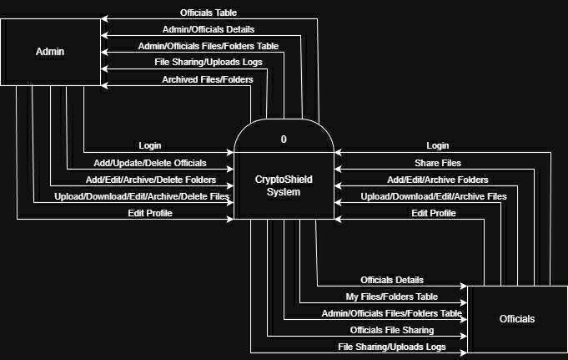
Figure 11. DFD Level 1
The figures above show the way information flows through the system. Figure 10 shows the overview of the entire system. Figure 11 shows what happens inside the system and how data moves between processes.

The Data Flow Diagram (DFD) and Use Case Diagram play crucial roles in understanding and designing the CryptoShield System. The use case diagram outlines the system’s functional scope, identifying the interactions between users and various system features. In contrast, the DFD provides a more detailed view of how data moves within the system, showing the processes, data stores, and data inputs/outputs. Together, these diagrams offer a comprehensive perspective, while the Use Case Diagram clarifies what the system does, the DFD explains how it processes and manages data to fulfill those functions.

Database Design

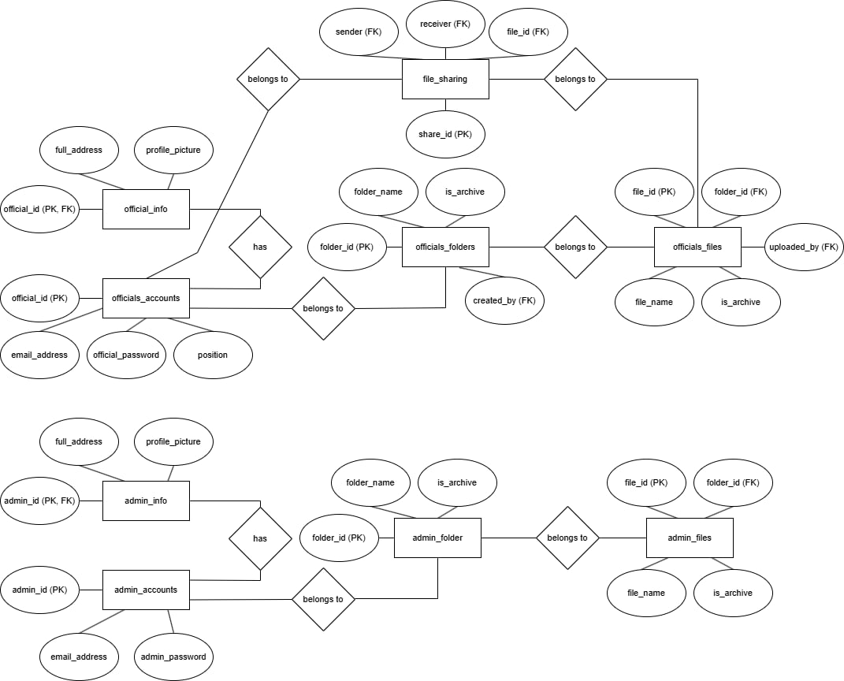

Figure 12. Entity Relationship Diagram
The database design of the CryptoShield: Data Encryption and Security System focuses on securely managing user data, file storage, and sharing functionalities for both officials and administrators. It is composed of two main sections: the Officials and Admin modules. Each module includes account and information tables that store login credentials and personal details, as well as folder and file tables that organize uploaded documents and manage archived records. The Officials_Accounts table links to the Official_Info, Officials_Folders, and Officials_Files tables, allowing officials to create folders, upload files, and share them through the File_Sharing table, which records the sender, receiver, and shared file details. Similarly, the Admin_Accounts table connects with Admin_Info, Admin_Folder, and Admin_Files to handle administrative document management. Overall, the design ensures secure data organization, controlled file access, and efficient information tracking within the system.

Security Considerations
- OTP Authentication
- Data Encryption
- End-to-end Encryption
- Secure File Sharing

Technology Stack
- Frontend: Css/Html
- Backend: JavaScript, PHP
- Database: MySQL

Survey Questionnaire for System Assessment
This survey is designed to assess the performance, usability, and overall satisfaction of our secure communication and file-sharing system. The system includes features such as user login, OTP verification, message encryption and decryption using RSA and AES, file encryption with malware scanning, and secure file sharing. Your feedback is valuable and will help us improve the system to better meet user needs and ensure a safe and reliable experience. Please answer the questions honestly based on your experience and be truthful and precise as you can when responding to the following questions.
Demographic Information

General Information
- Age: _______
- Gender:
☐ Male
☐ Female
☐ Prefer not to say
- Occupation: _____________________
- How often do you use secure communication/file-sharing platforms?
☐ Daily
☐ Weekly
☐ Occasionally
☐ Rarely
☐ Never
System Usability
- How easy was it to create and log into your account?
☐ Very Easy
☐ Easy
☐ Neutral
☐ Difficult
☐ Very Difficult
- How would you rate the OTP verification process?
☐ Very Efficient
☐ Efficient
☐ Neutral
☐ Inefficient
☐ Very Inefficient
- Was the user interface easy to navigate?
☐ Very Easy
☐ Easy
☐ Neutral
☐ Confusing
☐ Very Confusing
- Did you encounter any bugs or errors while using the system?
☐ Yes ☐ No
If yes, please describe: ___________________________

Encryption and Decryption
- How secure do you feel when sending encrypted messages through the system?
☐ Very Secure
☐ Secure
☐ Neutral
☐ Insecure
☐ Very Insecure
- Were you able to successfully decrypt messages sent to you?
☐ Yes, always
☐ Sometimes
☐ No
- How would you rate the speed of the encryption/decryption process?
☐ Very Fast
☐ Fast
☐ Acceptable
☐ Slow
☐ Very Slow

File Encryption and Malware Scanning
- How confident are you that files are safe from malware before being shared?
☐ Very Confident
☐ Confident
☐ Neutral
☐ Not Confident
☐ Very Unconfident
- Did the file encryption and decryption work as expected?
☐ Yes ☐ No
If no, please explain: ___________________________
- Was the time taken to encrypt and scan the file acceptable?
☐ Yes
☐ No

Secure File Sharing
- Were you able to share files securely with specific users?
☐ Yes
☐ No
- Could any unauthorized user access your encrypted files?
☐ Yes
☐ No
☐ Not Sure
- Do you feel your shared files were protected from unauthorized access?
☐ Very Protected
☐ Protected
☐ Neutral
☐ Vulnerable
☐ Very Vulnerable

Overall Experience
- How satisfied are you with the overall system performance?
☐ Very Satisfied
☐ Satisfied
☐ Neutral
☐ Unsatisfied
☐ Very Unsatisfied
- Would you recommend this system to others who need secure communication and file sharing?
☐ Definitely
☐ Probably
☐ Not Sure
☐ Probably Not
☐ Definitely Not
- Additional comments or suggestions:

Sampling Methods for Respondents
Stratified sampling will be used when selecting respondents for the respondents’ Inventory Management System in order to guarantee that all important organizational groupings are adequately represented. The following steps will comprise the sampling process:
- Defined Strata - The respondents will be divided into tiers according to their position within the organization.
- Sampling Within Strata - Participants will be chosen by random sampling from each of these strata. This guarantees that enough staff from different roles are represented and that the feedback captures the unique needs and experiences of each group.
- Sample Size - The total number of respondents to the survey will be chosen to comply with the project's requirements, guaranteeing a sample size that is essential to draw accurate conclusions. The ideal number of respondents will be at least 10 or more per group from FPOP employees.
- Survey Distribution - The distribution of the survey will be done through Google Forms, making it simple for all participants to access, and will be disseminated by direct communication, social media, or email with companies engaged in inventory control.

CHAPTER IV
Result and Interpretation
Throughout the development of the secure communication and file transfer system, the group faced numerous technical and operational issues, but we solved them by continuing to improve it.

Merging the RSA with AES encryption algorithms was one of the major problems. Coordinating the encryption keys was delicate, and so was performing several tests to ensure that no data would be lost or misinterpreted during transmission.

Another problem was the implementation of the One-Time Password (OTP) for the purpose of two-factor authentication. The system was required to deliver OTPs by email and, at the same time, make sure that they were only valid for a very short period of time. Initially, some OTPs were either late or not accepted; thus, the team had to fine-tune the email setup and the verification process.

The system also had to deal with performance issues in the encryption and decryption of large files. AES offered high security, but sometimes it was the cause of slow processing. The team tried various methods to optimize the code in order to have a system that was both fast and secure.

Moreover, it was very difficult to create a simple and user-friendly interface, which also had strong security measures. The user feedback led to numerous layout and design modifications to make the system more likable.

The team had to go through a lot of testing, research, and collaboration to overcome all these difficulties, and that led to the development of a secure and efficient system eventually.

Summary of the data sources and analysis methods used
The research data in this paper is collected from multiple sources, including activity logs, encryption recordings, and users. The primary data was gathered during the deployment of the Cryptoshield: Encryption and Security System’s database, which recorded encryption and decryption, key management, and user authentication during its testing.

In addition to data from activity logs and associated recordings, we conducted surveys with users as well as system and barangay officials to obtain feedback on usability, security, and operation.

The analysis used a quantitative method. Quantitative data—encryption and decryption time, latency, and number of errors—were analyzed to measure overall performance and reliability of the Cryptoshild system. Receive feedback and then collect, which is organized and interpreted to measure ease of use, functionality, and perceived security of the system. This combined analytical approach helped to create a user-friendly view of Cryptoshield: Encryption and Security Systems.
Task Manager:

Gantt Chart / Project Timetable – Cryptoshild: Encryption and security system

Week | Task | Programer | UI/UX Designer | Documenter
1 | Project planning & requirements gathering | ✅ | ✅ | ✅
2 | Research & system design planning | ✅ | ✅ | ✅
3 | Use Case & DFD creation |  | ✅ | ✅
4 | Database design & schema creation | ✅ | ✅ | ✅
5 | UI wireframes & mockups | ✅ | ✅
6 | Frontend development begins | ✅ | ✅
7 | Backend development begins | ✅
8 | Integration of frontend and backend | ✅ | ✅
9 | System testing & debugging | ✅
10 | User testing & feedback collection | ✅ | ✅ | ✅
11 | Final revisions (code + UI + content) | ✅ | ✅ | ✅
12 | Documentation finalization & formatting, Final project submission | ✅ | ✅ | ✅

✅ Legend:
- ✅ Active Role in that week

4.1 Presentation of Results
The CryptoShield Encryption and Security System was designed, tested, and evaluated to assess its capability to protect data, ensure the confidentiality of information, and guard against unauthorized access. Once implemented, results were obtained through system security testing, testing the performance of the encryption methods, and user evaluation. The system was evaluated based on how well it protected data, the speed of encryption and decryption, and user feedback and satisfaction to demonstrate that CryptoShield provided a secure, efficient, and reliable system for protecting data.

CHAPTER V
Summary, Conclusion, and Recommendation
Summary
The study conducted is aimed at developing a secure communication and file-sharing system that is capable of providing data protection using AES encryption and implementing multi-layered security measures. One of the notable aspects of the system is its user-friendly interface, which has been developed in such a way that it facilitates the use of the system while at the same time offering strong protection for the sensitive data. The system has incorporated a secure login process that makes use of One-Time Password (OTP) verification in order to eliminate the chances of unauthorized access. The system applies AES encryption to messages and files; thus, confidentiality of data is guaranteed, and only users with the appropriate authorization can access it.

Conclusion
The secure communication and file transfer system's development made it possible to attain the main goal— a platform that is safe, reliable, and easy to use for the exchange of messages and files. The AES encryption guarantees the protection of all data that is sent against unauthorized users. The implementation of One-Time Password (OTP) authentication has made account security even stronger, hence lessening the chances of a breach.

In conclusion, the project has shown the possibility of designing a communication system with the right mix of security and usability. The creators of the system, by carrying out an elaborate design and testing, managed to deliver on their promise of making user information safe while still offering efficiency and convenience.

Recommendations
- Implement Additional Authentication Methods:
Future improvements might consist of biometric or authenticator app-based verification, for example, fingerprint or Google Authenticator, which will make user authentication even stronger.
- Optimize System Performance:
AES encryption indeed slows down the processing of large files, but you can still look for further optimization techniques or hardware acceleration to speed up the process.
- Add Data Backup and Recovery Features:
The addition of secure cloud-based storage or automatic data recovery can be a great help in keeping the encrypted files safe in the event of system failure or data loss.
- Enhance the User Interface:
Continuous user feedback should be the primary guiding factor for improvement, ensuring the platform remains simple, accessible, and visually appealing for both technical and non-technical users.
- Conduct Large-Scale Testing:
The system should be subjected to heavy loads for testing by future researchers and developers to determine the scalability, network stability, and encryption performance.

Final Thoughts
The entire process of this capstone project has thus far opened a new way towards secure digital communication and data transfer. With the continued growth and expansion of online interactions, the safeguarding of privacy and sensitive information has become a necessity rather than a luxury.

The research concludes that strong encryption, for instance, AES, along with multi-layered authentication, can significantly reduce the chances of unauthorized access and data leaks. However, besides the technology's success, the project still emphasizes that the technology must always weigh security against usability and trust.

Eventually, such systems will be part of the digital world's safety measures—making it possible for people, organizations, and institutions to communicate and collaborate without fear of information leakage.

